* ~~Track and Display overall winner~~
* Offer the player the option to play again or end the game

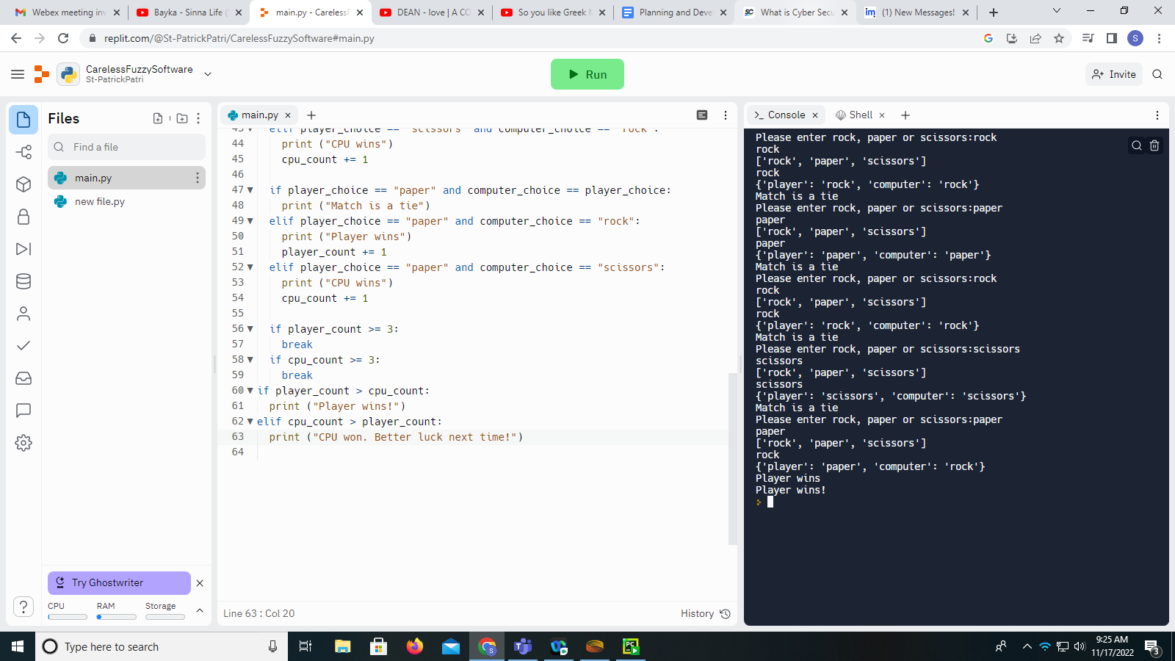

Janken V 1.0

~~Programme is currently calculating based on whatever result comes last in the iteration~~.

It also doesn’t seem like the breaks are actually being observed within the programme, however there’s no error meaning they are connected to something.

~~We can also stop displaying the player choice separately~~

~~Both player_count and cpu_count only actually increment on the 5th instance of the loop.~~

~~When they should actually be incrementing based on the count~~

~~No actually, they both re-increment so we need to make it so the increment is stored~~

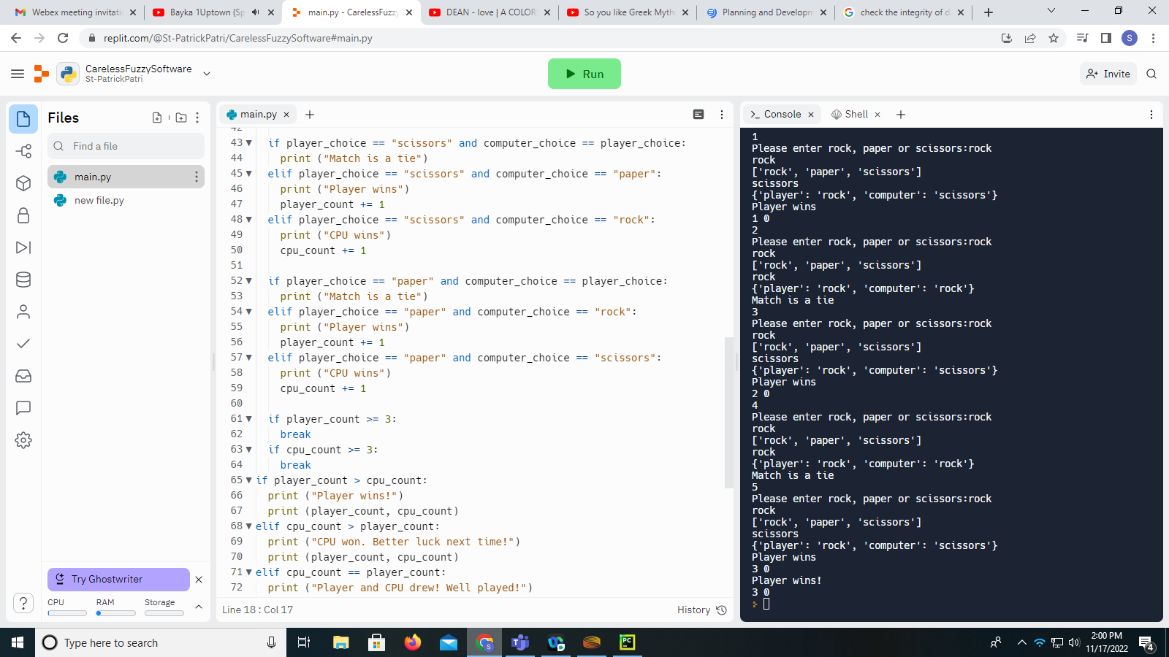

Janken V 1.2

Break’s still not being implemented

Orchestrate a restart or end “button”

~~Clean up the source code~~

* ~~Stop displaying the user input~~
* ~~Stop displaying the player and cpu count~~
* ~~Stop displaying “options”~~
* ~~Stop displaying the increment count~~
* ~~Stop displaying the cpu input~~

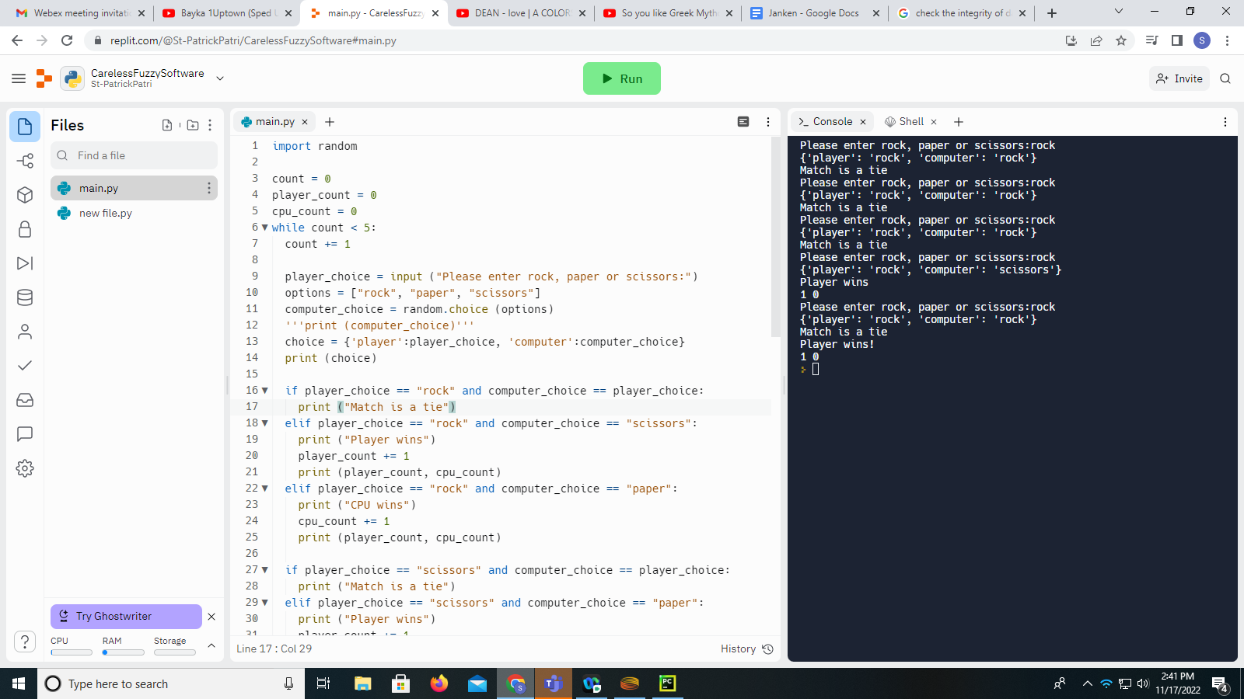

Janken V 1.3